**Windows Navigation Diagram**

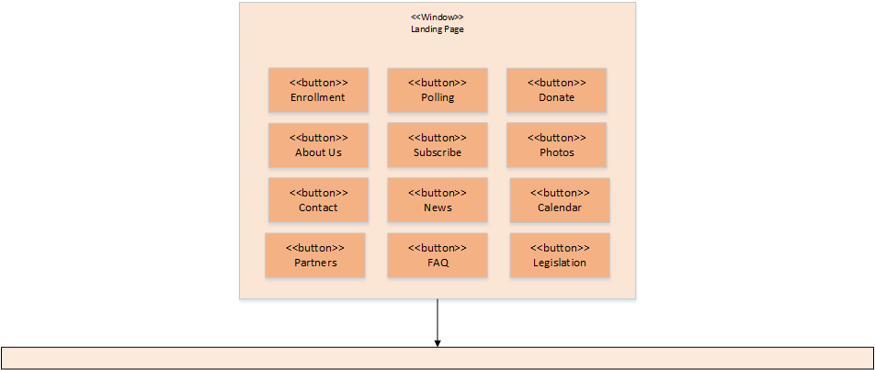

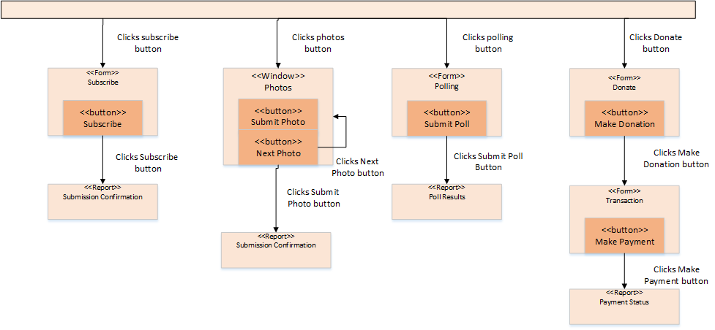

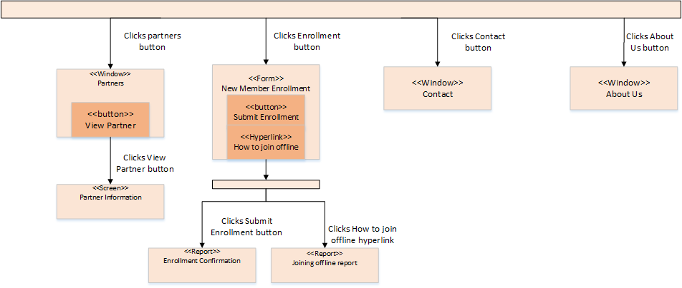

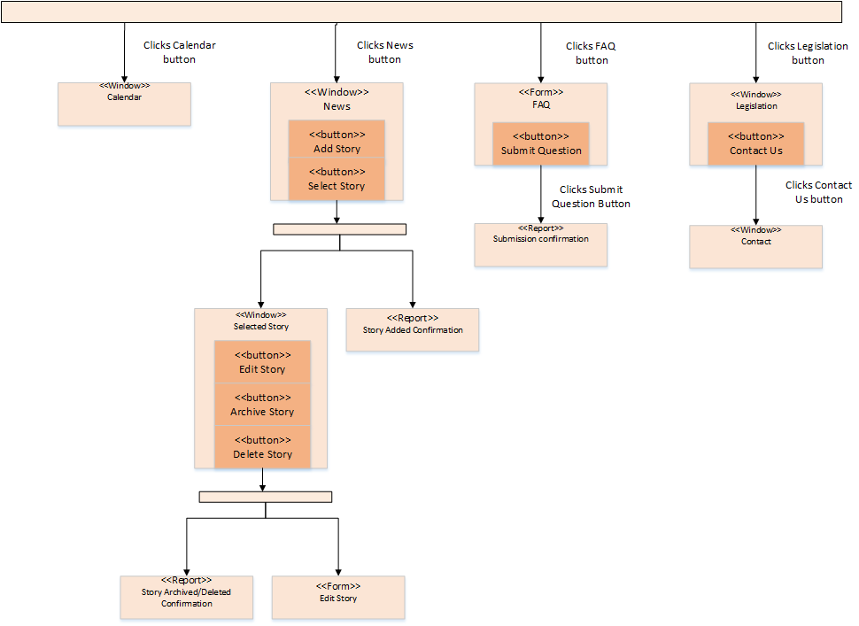

**Input Screen Layouts**

New Member Enrollment Form

This is what the new member enrollment form could look like. It captures all the required information for a person to join the KYHBPA.

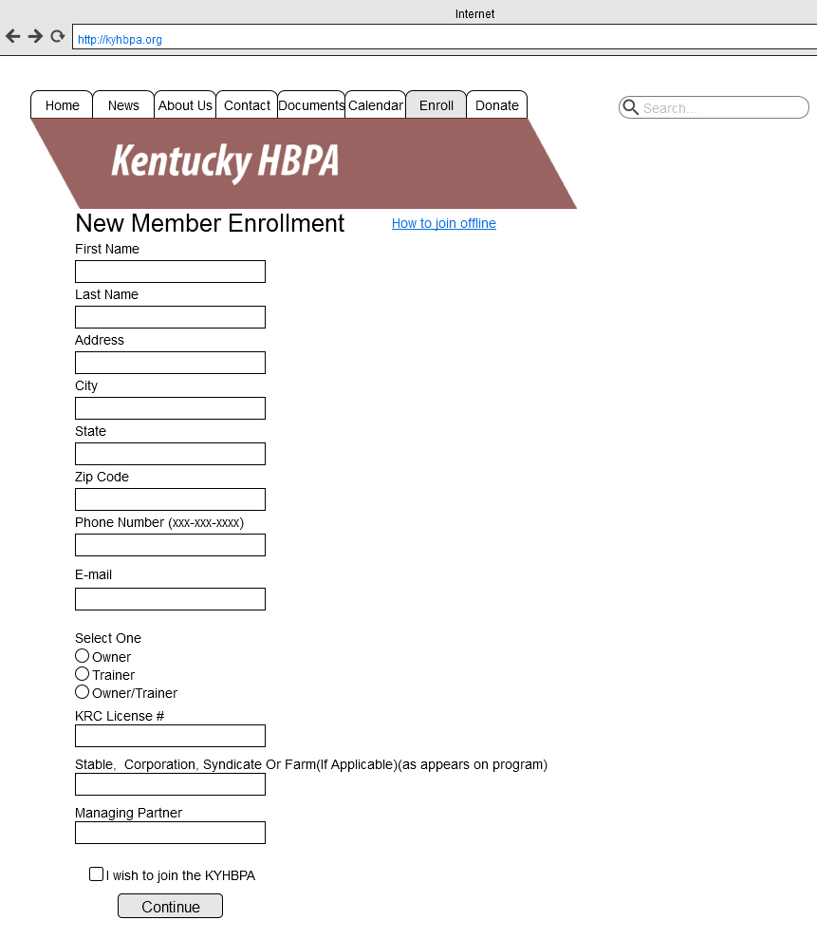

Polling Form

This screen realizes the use case by allowing the KHBA to collect information from its users on relevant topics.

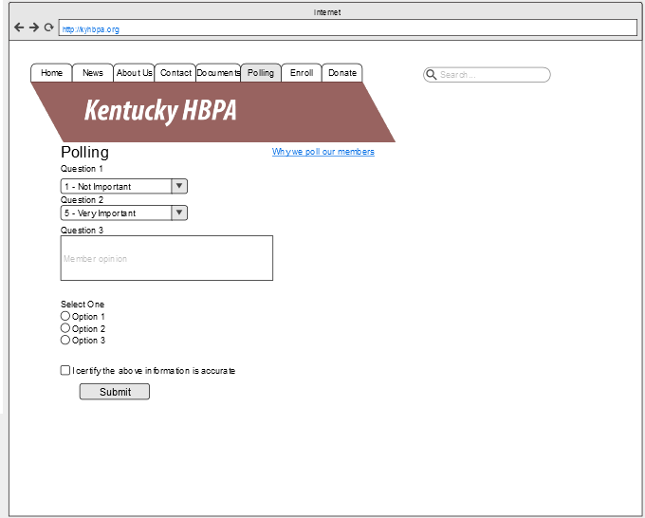

Subscribe Form

This screen realizes the use case by allowing a user to electronically subscribe to the KHBPA newsletter.

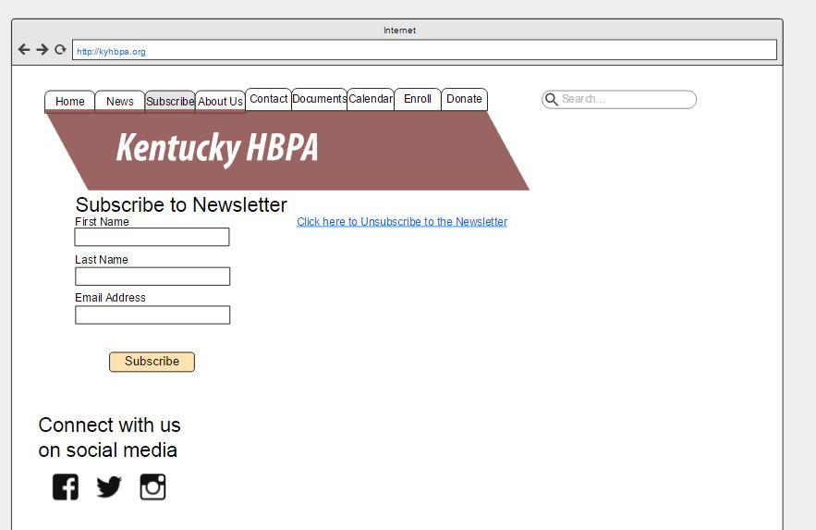

Donate Form

This screen realizes the use case by allowing a donor to make a donation online.

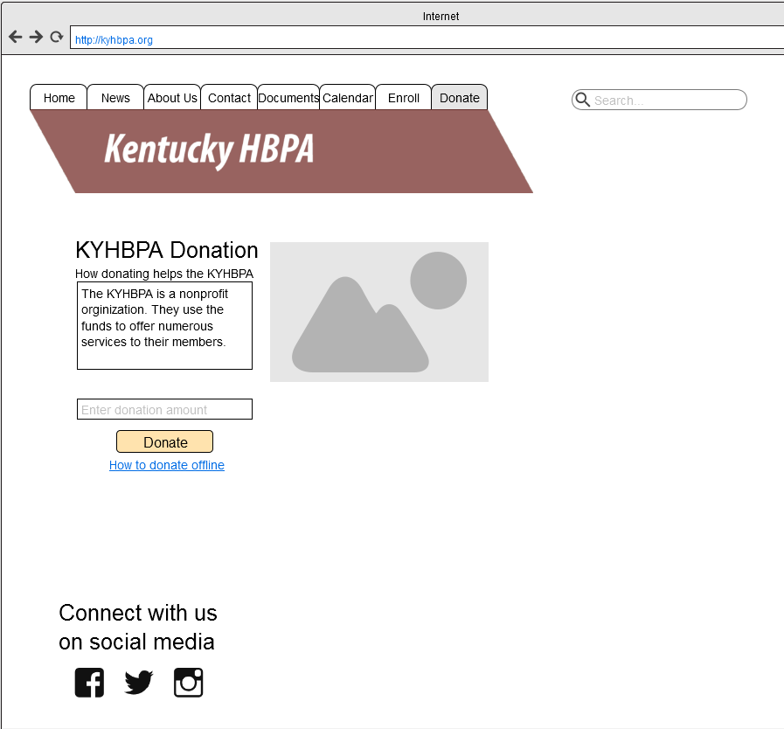

Transaction Form

This screen realizes the use case by allowing a payment to be made through an online payment processing system.

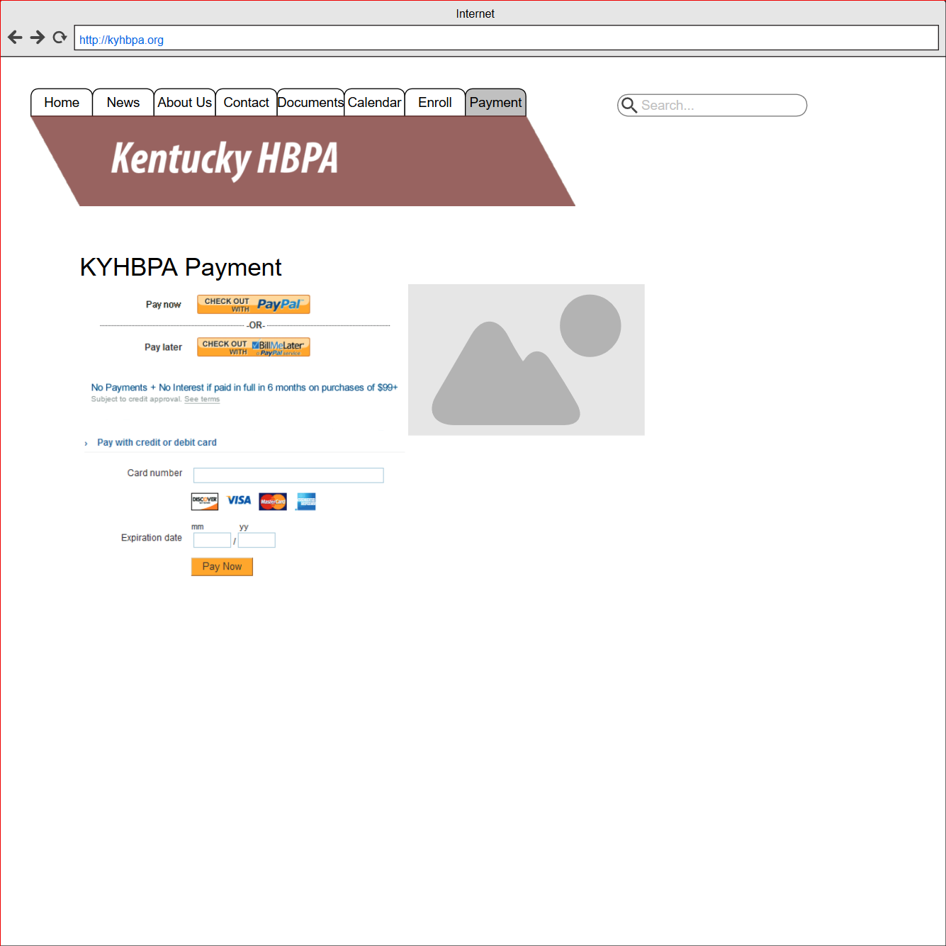

FAQ Form

This screen realizes the use case by allowing users to submit and view questions.

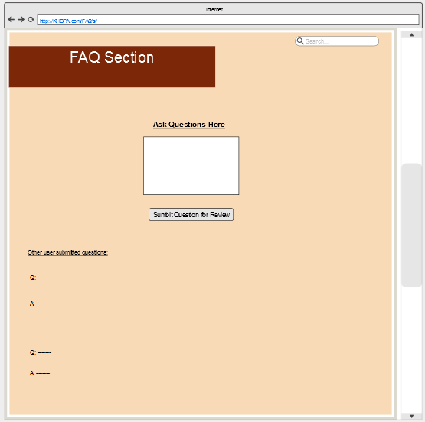

**Output Screen Layouts**

Provide screen layouts for input screens/forms (data capture) and output screens/reports (data presentation).  Layouts may be borrowed from the HTML prototype (recommended) or presented in storyboard form.  Explain how the screen layouts realize the use cases.

Joining Offline Report

This screen provides information about how to join the KYHBPA offline.

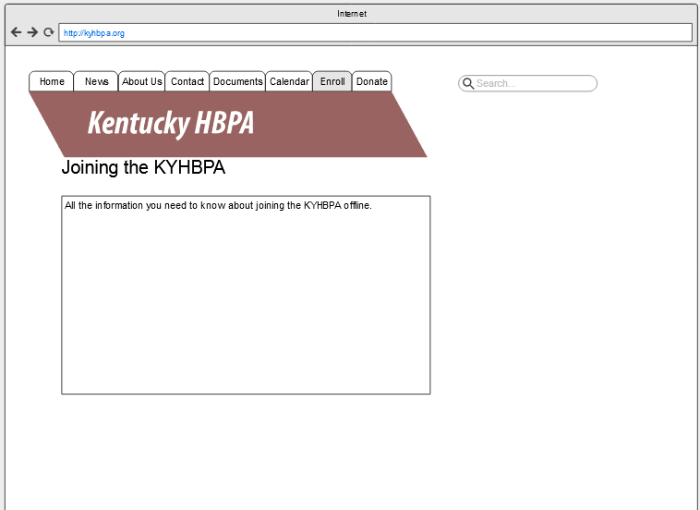

Partner Information Report

This screen realizes the use case by providing information about a selected partner.

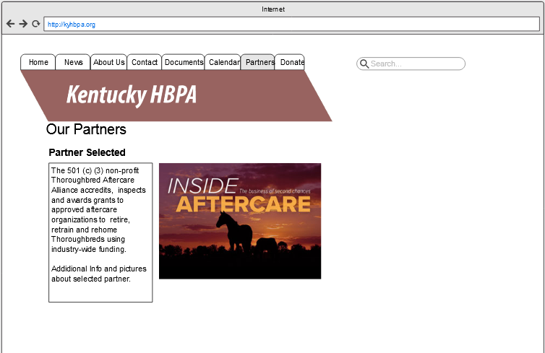

Contact Screen

This screen provides all the information users may need to contact the KYHBPA.

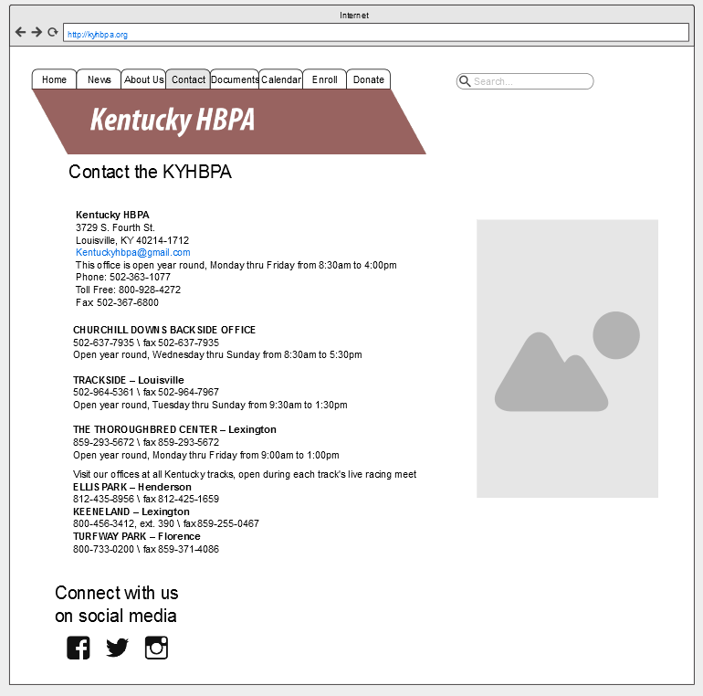

About Us Screen

This screen realizes the use case by providing information about the purpose and history of the KHBPA.

